**C++ and Java Programming MINI PROJECT REPORT**

## DON BOSCO INSTITUTE OF TECHNOLOGY



**Skill Lab: C++ and Java Programming MINI PROJECT REPORT**

**On**

**“Moving Car”**

**2021-22**

**Submitted By:**

Nimesh Ambre (Group Leader) Roll no = 17

Rishi Dubey Roll no = 29

Under the guidance of Ms. Deepali Kayande

**C++ and Java Programming MINI PROJECT REPORT**

**Mini Project Title : Moving Car**

**Institute Name : Don Bosco Institute of Technology.**

**Institute Address : Premier Automobiles Road,**

**Kurla (West), Mumbai – 400070**

**Department : EXTC Class : SE**

**Project Group Members :**

|  |
| --- |
| **Names of students Roll No.** |
| **1. Nimesh Ambre (Group Leader) 17**  **2. Rishi Dubey 29** |

**Date of Submission : 10/12/21**

**Prof : Ms. Deepali Kayande**

**C++ and Java Programming MINI PROJECT REPORT**

**TABLE OF CONTENTS**

|  |  |
| --- | --- |
| **SR. NO.** | **CONTENT** |
| **CHAPTER 1** | INTRODUCTION |
| **CHAPTER 2** | PROBLEM DEFINITION |
| **CHAPTER 3** | IMPLEMENTATION |
| **CHAPTER 4** | RESULTS(SNAPSHOTS) |
| **CHAPTER 5** | CONCLUSION |

**C++ and Java Programming MINI PROJECT REPORT**

# CHAPTER 1

## INTRODUCTION

We came up with the project idea when we were having conversation on a game and as we haven’t learned

A lot to code so we came up with this basic idea of creating a game.

It’s our first step towards game development and its called MOVING CAR.

Bascially its just a car with shapes and a road but later will try to build a complete game from it

**C++ and Java Programming MINI PROJECT REPORT**

# CHAPTER 2

## PROBLEM DEFINITION MODULES

1. The main problem faced by our group in a starting was Communication with each other timming didn’t match .
2. After deciding the topic, main issue was from where to start and how ? After referring the Youtube and google we figure it out.
3. After we implement code in Dev-C++ programming software there were some errors ,

Then we decided to try it in java so we have both the knowledge.

1. Coding in C++ was easier than java it took many days to solve 15 errors as we had to download old version and use some new software

pg. 5

**C++ and Java Programming MINI PROJECT REPORT**

# CHAPTER 3

# IMPLEMENTATION

There is nothing big in this but we wanted everyone to see it and feel coding is easy and not at all difficult.

We had to download directory upload it in the project file change few settings to solve the errors.

Our game will be fun for primary kids as when they are in lab they can just type in their specific characters and boom make their type of moving ”Anything”

**Link GitHub for code:-** https://github.com/Nimesh-Ambre/Skill-Lab-with-OOPM

**C++ and Java Programming MINI PROJECT REPORT**

CODE :

|  |
| --- |
| package javaapplication10; |
|  |  |
|  | import java.applet.*; |
|  | import java.awt.*; |
|  | import java.lang.*; |
|  |  |
|  | /*applet code="Car" height=800 width=700></applets>*/ |
|  | public class Car extends Applet |
|  | { |
|  | int x,y,w; |
|  | void slep() |
|  | { |
|  | try{ |
|  | Thread.sleep(200); |
|  | }catch(Exception ob){} |
|  | } |
|  |  |
|  | public void init() |
|  | { |
|  | y=30; |
|  | x=20; |
|  | } |
|  | public void paint(Graphics g) |
|  | { |
|  | setBackground(Color.pink); |
|  | w=getWidth(); |
|  | Color c1=new Color(20,160,200); |
|  | Color c2=new Color(200,60,200); |
|  | g.setColor(c1); |
|  |  |
|  | g.drawLine(0,y+75,w,y+75); |
|  | g.setColor(c2); |
|  | g.fillRoundRect(x+90,y+20,20,40,270,180); |
|  | g.setColor(c1); |
|  |  |
|  |  |
|  | g.fillRoundRect(x+10,y,70,25,10,10); |
|  | g.setColor(Color.white); |
|  | g.fillRect(x+20,y+5,20,25); |
|  | g.setColor(Color.black); |
|  | g.fillRoundRect(x+55,y+5,10,20,10,10); |
|  | g.fillOval(x+10,y+50,25,25); |
|  | g.fillOval(x+60,y+50,25,25); |
|  | g.setColor(Color.white); |
|  | g.fillOval(x+15,y+55,10,10); |
|  | g.fillOval(x+65,y+55,10,10); |
|  |  |
|  |  |
|  |  |
|  | x=x+10; |
|  | slep(); |
|  |  |
|  | if(x+100 < w) |
|  | { |
|  | repaint(); |
|  | } |
|  | else |
|  | { |
|  | repaint(); |
|  | x=20; |
|  | y+=30; |
|  | } |
|  | } |
|  | // <editor-fold defaultstate="collapsed" desc=" Generated Code "> |
|  | private void initComponents() { |
|  |  |
|  | setLayout(new java.awt.BorderLayout()); |
|  |  |
|  | } |
|  | // </editor-fold> |
|  |  |
|  | } |
|  | // Variables declaration - do not modify |
|  | // End of variables declaration |

**C++ and Java Programming MINI PROJECT REPORT**

# CHAPTER 4

## RESULT

Output:

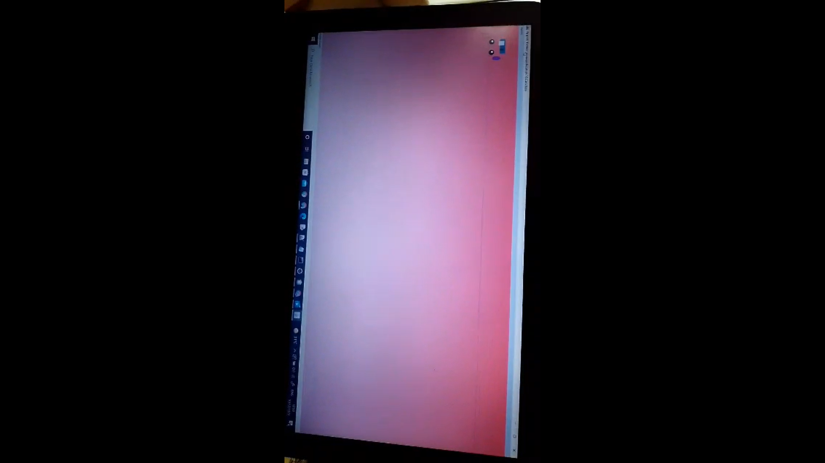

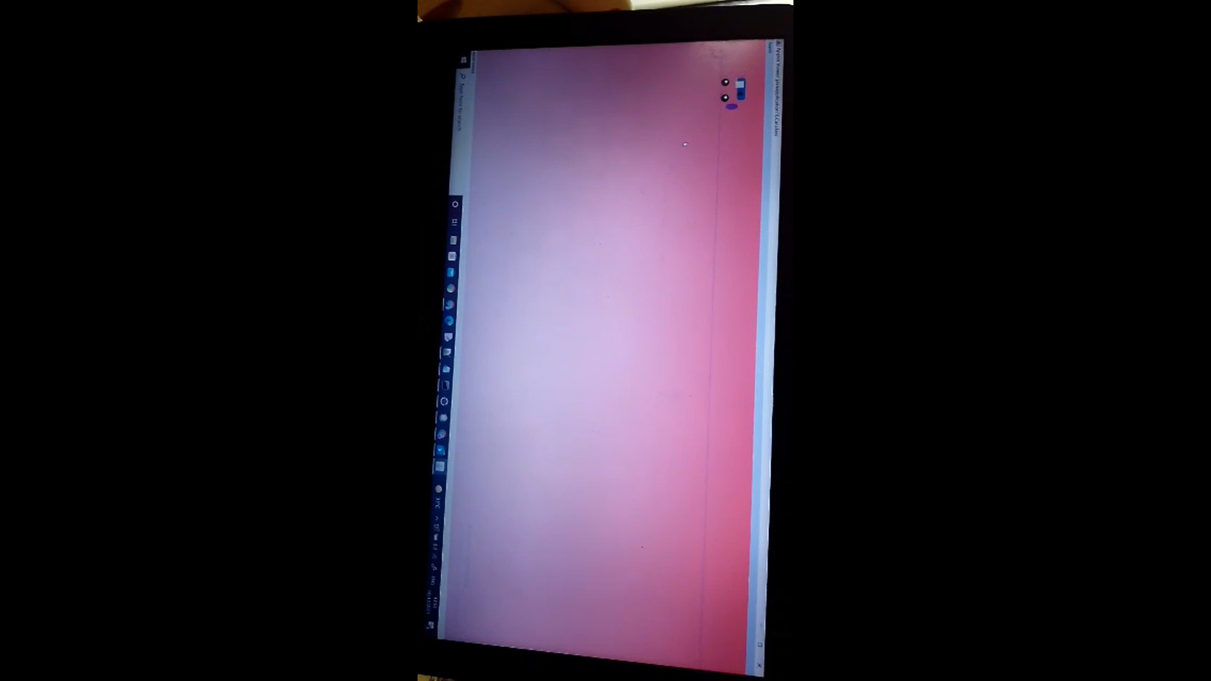

**C++ and Java Programming MINI PROJECT REPORT**

# CHAPTER 5

## CONCLUSION

It’s better to makes games in C++ than java , and this project will help entertaining children, so we made a basic game

## *THANK YOU*